**DBMS LAB**

**ASSIGNMENT-10**

**SNEHA SINGH**

**20198023**

**IT 5 B2**

**Q. Create the following tables:**

Create table Emp_Detail (employee_id number(4), first_name varchar2(10), last_name varchar2(4), Salary number(30), dept_id number(5) );

insert into Emp_Detail values(1,'John', 'aaa1',10000,11);

insert into Emp_Detail values(2,'Dennis', 'b1',8000,12);

insert into Emp_Detail values(3,'Albert', 'c1',11000,13);

insert into Emp_Detail values(4,'Charles', 'd1',7000,14);

insert into Emp_Detail values(5,'Richard','e1',17000,15);

Create table Department (Dept_name varchar2(10), Manager_id number(4), dept_id number(5));

insert into Department values('LMNT','111',1000);

insert into Department values('SRTC', '222',100);

insert into Department values('STORE', '333',1100);

insert into Department values('TEST', '444',700);

insert into Department values('ENQIRY','555',1700);

**1.Implicit Cursor:**

**a) Write a program in PL/SQL, using a cursor display all information of employee having emp id 5 from emp_detail table.**

DECLARE

employee_id Emp_Detail.employee_id%type;

first_name Emp_Detail.first_name%type;

last_name Emp_Detail.last_name%type;

salary Emp_Detail.salary%type;

dept_id Emp_Detail.dept_id%type;

dept_name Department.dept_name%type;

manager_id Department.manager_id%type;

cursor c_emp is select employee_id, first_name, last_name, salary, dept_id from Emp_Detail where

employee_id=5;

BEGIN

open c_emp;

loop

fetch c_emp into employee_id, first_name, last_name, salary, dept_id;

exit when c_emp%notfound;

dbms_output.put_line(employee_id||' '||first_name||' '||last_name||' '||salary||' '||dept_id);

end loop;

close c_emp;

end;

/

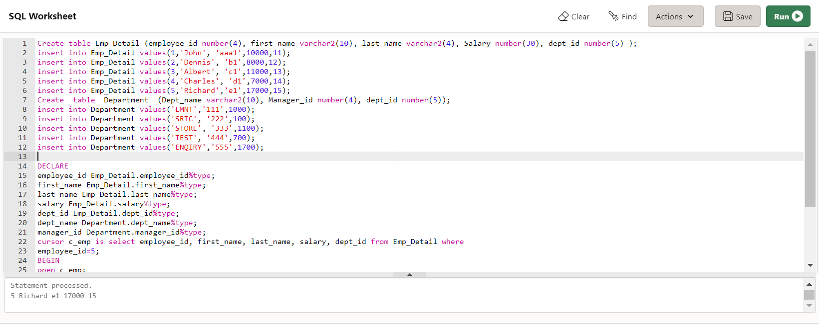

**b) Write a program in PL/SQL, using an implicit cursor with for loop, display the first name, dept id and dept name of employees having salary more than 5000.**

BEGIN

FOR item IN(SELECT dept_name,d.dept_id,last_name,salary

FROM department d JOIN emp_detail e

ON e.dept_id = d.dept_id

WHERE salary > 5000)

LOOP

DBMS_OUTPUT.PUT_LINE(item.last_name||' '||item.dept_name

||' '||item.dept_id||' '||' '||item.salary);

END LOOP;

END;

/

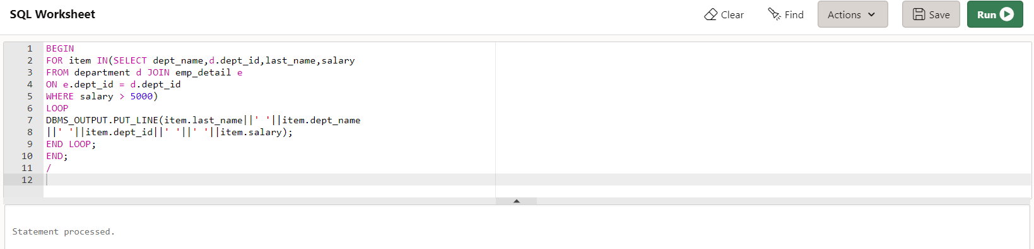

**2.Explicit Cursor:**

declare

employee_id Emp_Detail.employee_id%type;

first_name Emp_Detail.first_name%type;

last_name Emp_Detail.last_name%type;

salary Emp_Detail.salary%type;

dept_id Emp_Detail.dept_id%type;

dept_name Department.dept_name%type;

manager_id Department.manager_id%type;

cursor c_emp is select employee_id, first_name, last_name, salary, dept_id from Emp_Detail;

begin

open c_emp;

loop

fetch c_emp into employee_id, first_name, last_name, salary, dept_id;

exit when c_emp%notfound;

dbms_output.put_line(first_name||' '||last_name||' '||salary);

end loop;

close c_emp;

end;

/

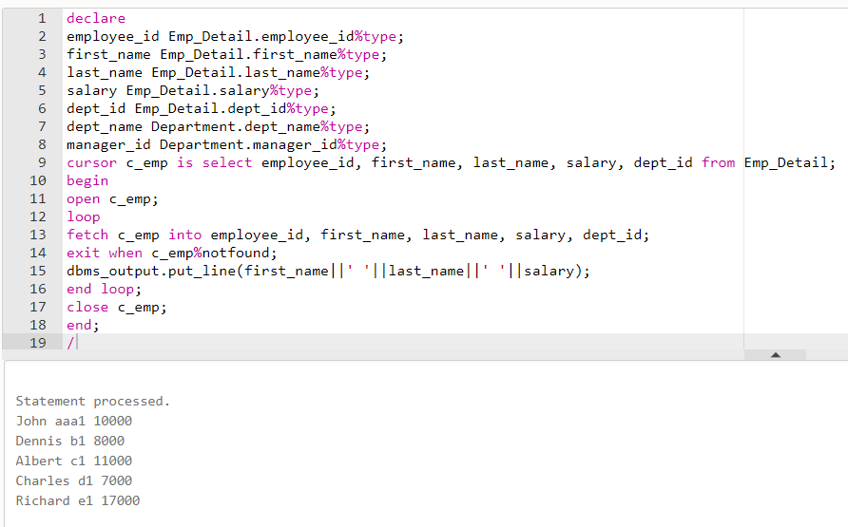

**a) Write a program in PL/SQL using an explicit cursor, retrieve the records from the emp_detail table and display the details of employees whose salary is more than 8000.**

declare

employee_id Emp_Detail.employee_id%type;

first_name Emp_Detail.first_name%type;

last_name Emp_Detail.last_name%type;

salary Emp_Detail.salary%type;

dept_id Emp_Detail.dept_id%type;

dept_name Department.dept_name%type;

manager_id Department.manager_id%type;

cursor c_emp is select employee_id, first_name, last_name, salary,dept_id from Emp_Detail where

salary>8000;

begin

open c_emp;

loop

fetch c_emp into employee_id, first_name, last_name, salary, dept_id;

exit when c_emp%notfound;

dbms_output.put_line(employee_id||' '||first_name||' '||last_name||' '||salary||' '||dept_id); end loop;

close c_emp;

end;

/

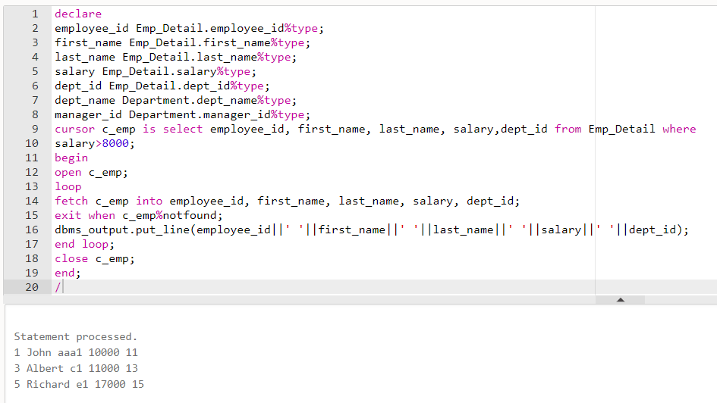

**b) Write a PL/SQL block, using a cursor attribute to update the table & increase salary of each customer by 2000.**

declare

employee_id Emp_Detail.employee_id%type;

first_name Emp_Detail.first_name%type;

last_name Emp_Detail.last_name%type;

salary Emp_Detail.salary%type;

dept_id Emp_Detail.dept_id%type;

dept_name Department.dept_name%type;

manager_id Department.manager_id%type;

cursor c_emp is select employee_id, first_name, last_name, salary, dept_id from Emp_Detail for

update;

begin

open c_emp;

loop

fetch c_emp into employee_id, first_name, last_name, salary, dept_id;

exit when c_emp%notfound;

update Emp_Detail set salary = salary + 2000 where current of c_emp;

dbms_output.put_line(employee_id||' '||first_name||' '||last_name||' '||salary||' '||dept_id);

end loop;

close c_emp;

end;

/

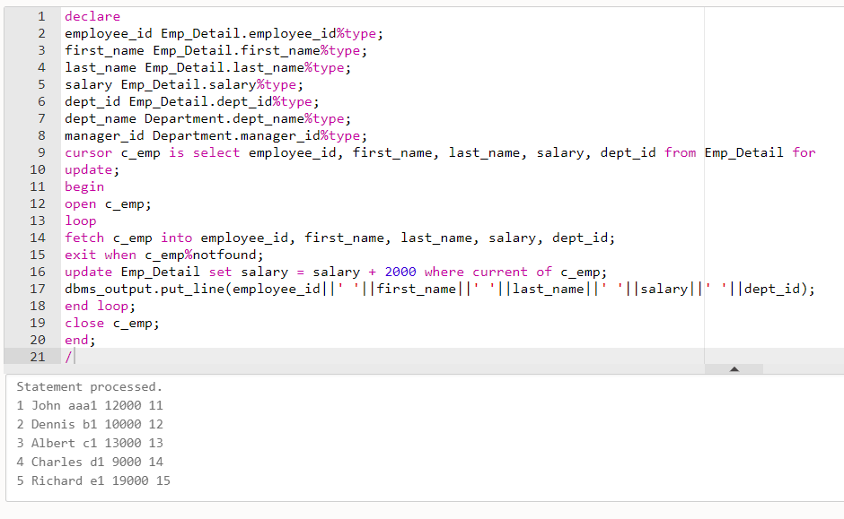

**3.Procedure & Function:**

**a) Create a procedure to find the minimum of two values, which are passed to it using IN mode and returns their minimum value using OUT parameters.**

DECLARE

a number;

b number;

c number;

PROCEDURE findMin(x IN number, y IN number, z OUT number) IS

BEGIN

IF x < y THEN

z:= x;

ELSE

z:= y;

END IF;

END;

BEGIN

a:= 23;

b:= 45;

findMin(a, b, c);

dbms_output.put_line(' Minimum of (23, 45) : ' || c);

END;

/

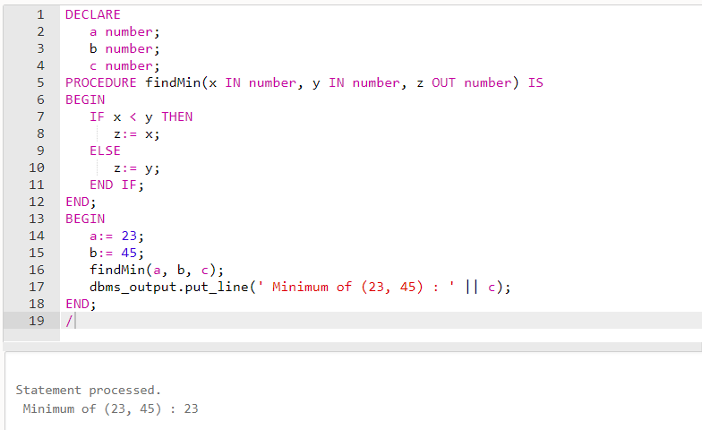

**b) Create and call a standalone function where this function returns the total number of customers from the Customers table.**

create table customers (ID number(10), name varchar2(10), age number(10), address varchar2(10), Salary Float);

insert into customers values(101,'John',32,'Lodan',20000.00);

insert into customers values(3,'Clerk',25,'Paris',15000.00);

insert into customers values(4,'Mark',22,'New York',85000.00);

insert into customers values(5,'Albert',29,'California',45000.00);

-- Declare function total_customers

create or replace function total_customers return number is

total number(2) := 0;

begin

select count(*) into total from customers;

return total;

end;

/

-- Anonymus block to call function

begin

dbms_output.put_line('Total Customers in customers table is '|| total_customers());

end;

/

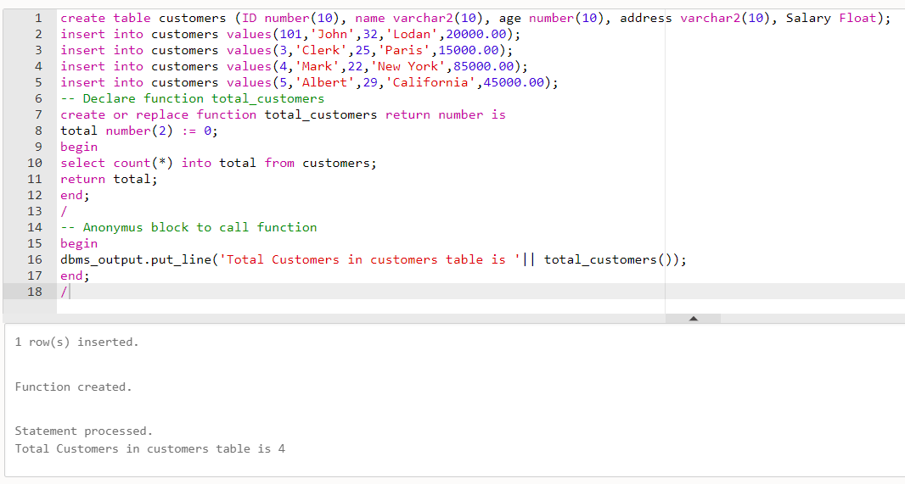

**c) Create a function to calculate the factorial of a given number. The function should call itself recursively.**

DECLARE

num number;

factorial number;

FUNCTION fact(x number)

RETURN number

IS

f number;

BEGIN

IF x=0 THEN

f := 1;

ELSE

f := x * fact(x-1);

END IF;

RETURN f;

END;

BEGIN

num:= 6;

factorial := fact(num);

dbms_output.put_line(' Factorial '|| num || ' is ' || factorial);

END;

/

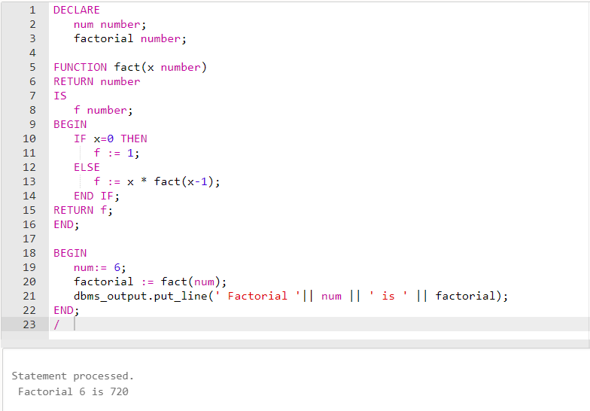

**d) Create two procedures within a procedure and call them. Both should print the messages which distinguish them from each other.**

-- Create outside_procedure and two inside_procedure

create or replace

procedure outside_procedure

is

procedure inside_procedure1

is

begin

dbms_output.put_line('inside_procedure1');

end;

procedure inside_procedure2

is

begin

dbms_output.put_line('inside_procedure2');

end;

begin

dbms_output.put_line('outside_procedure');

inside_procedure1;

inside_procedure2;

end;

-- Call outside_procedure using exec

exec outside_procedure;

**-- Output : outside_procedure**

**-- inside_procedure1**

**-- inside_procedure2**